March monthly report
Project Title:
Conversion of post-combustion gas from cement manufacturing to syngas by electrochemical CO₂ capture and reduction
……..........................................................
Dr. Pongkarn Chakthranont
Sothearoth Heng
NCR ID: 803198
Under the supervision of
Dr. Pongkarn Chakthranont
Contract Number: NCR-NN-2023-20170-EN
April 2024

- Tasks list for March
- Synthesis of Ni₂-2D-NOC with a Ni-phc:Urea:Dicy ratio of 2:5:5
- CO2RR performance measurement of as-prepared Ni₂-2D-NOC
- Investigation of CO2RR performance of Ni-2D-NOC with different mass loading (0.65, 0.9, and 1.2 mg/cm²)
- Literature review on Ni single atom catalysts for electrochemical reduction of CO₂ to CO
- Experimental Procedure
Synthesis of Ni₂-2D-NOC catalyst via pyrolysis method
The synthesis of Ni-2D-NOC catalyst was completely followed the previous report.¹ Initially, Ni-Phc, Urea, and Dicy (weight ratio of 2:5:5) were ground-mixed thoroughly together. Then, the mixture was placed in a quartz boat that was closed with a lid and pyrolyzed at 800 °C (ramp rate = 10 °C·min^{–1}) in a tube furnace under an Ar atmosphere (flow rate = 200 sccm) for 2h.

Preparation of the Ni₂-2D-NOC cathode electrode via spray coating method
The as-prepared Ni₂-2D-NOC catalyst was spray-coated onto Sigracet 36BB carbon paper. Briefly, 50 mg of the Ni-2D-NOC and 127µL or 10% by catalyst weight of XA-9 binder were ultrasonically mixed with IPA for 30 min to form a dark colloidal solution which then was sprayed onto Sigracet 39BB carbon paper with 0.5 ml/min on 95 °C hotplate to obtain ~ 0.5 ± 0.15 mg/cm².

Electrochemical CO2RR measurements
A 5 cm² MEA electrolyzer was used to evaluate the CO2RR performance under modulated operating conditions. The Ni foam, AEM (X37-50 Grade RT, Dioxide Materials), and Ni-2D-NC cathode catalyst were employed as the anode, membrane, and cathode electrode, respectively. 50 ml of 0.5M KOH was recirculated and used throughout the experiment as the anolyte at 8 ml/min. Different humidified gas feed compositions was introduced into the cathodic inlet under various flow rates. The cathodic outlet was directly injected into an online gas-chromatography for further gas products analysis.

- Results
CO2RR performance of Ni₂-2D-NC and other cathode materials
We initially screened the CO₂ reduction reaction (CO2RR) performance of various Ag-based catalysts and single-atom M-2D-NOC catalysts at a current density of 200 mA/cm² and a CO₂ flow rate of 150 ml/min (as shown in Fig. 1). Based on the hypothesis that higher Ni loading enhances catalyst performance by increasing active sites, we further investigated a single Ni atom catalyst with a higher Ni content (Ni₂-2D-NC) to determine the optimal Ni loading. However, Ni₂-2D-NC exhibited minimal differences in faradaic efficiency (FE) compared to Ni₁-2D-NC, with an FE(CO) of 96% and an FE(H₂) of 4%. This suggests that the Ni₁-2D-NC catalyst prepared with a Ni-Phc:Dicy:Urea ratio of 1:5:5 represents the optimal synthesis condition, as higher Ni loading appears to have minimal impact on performance.
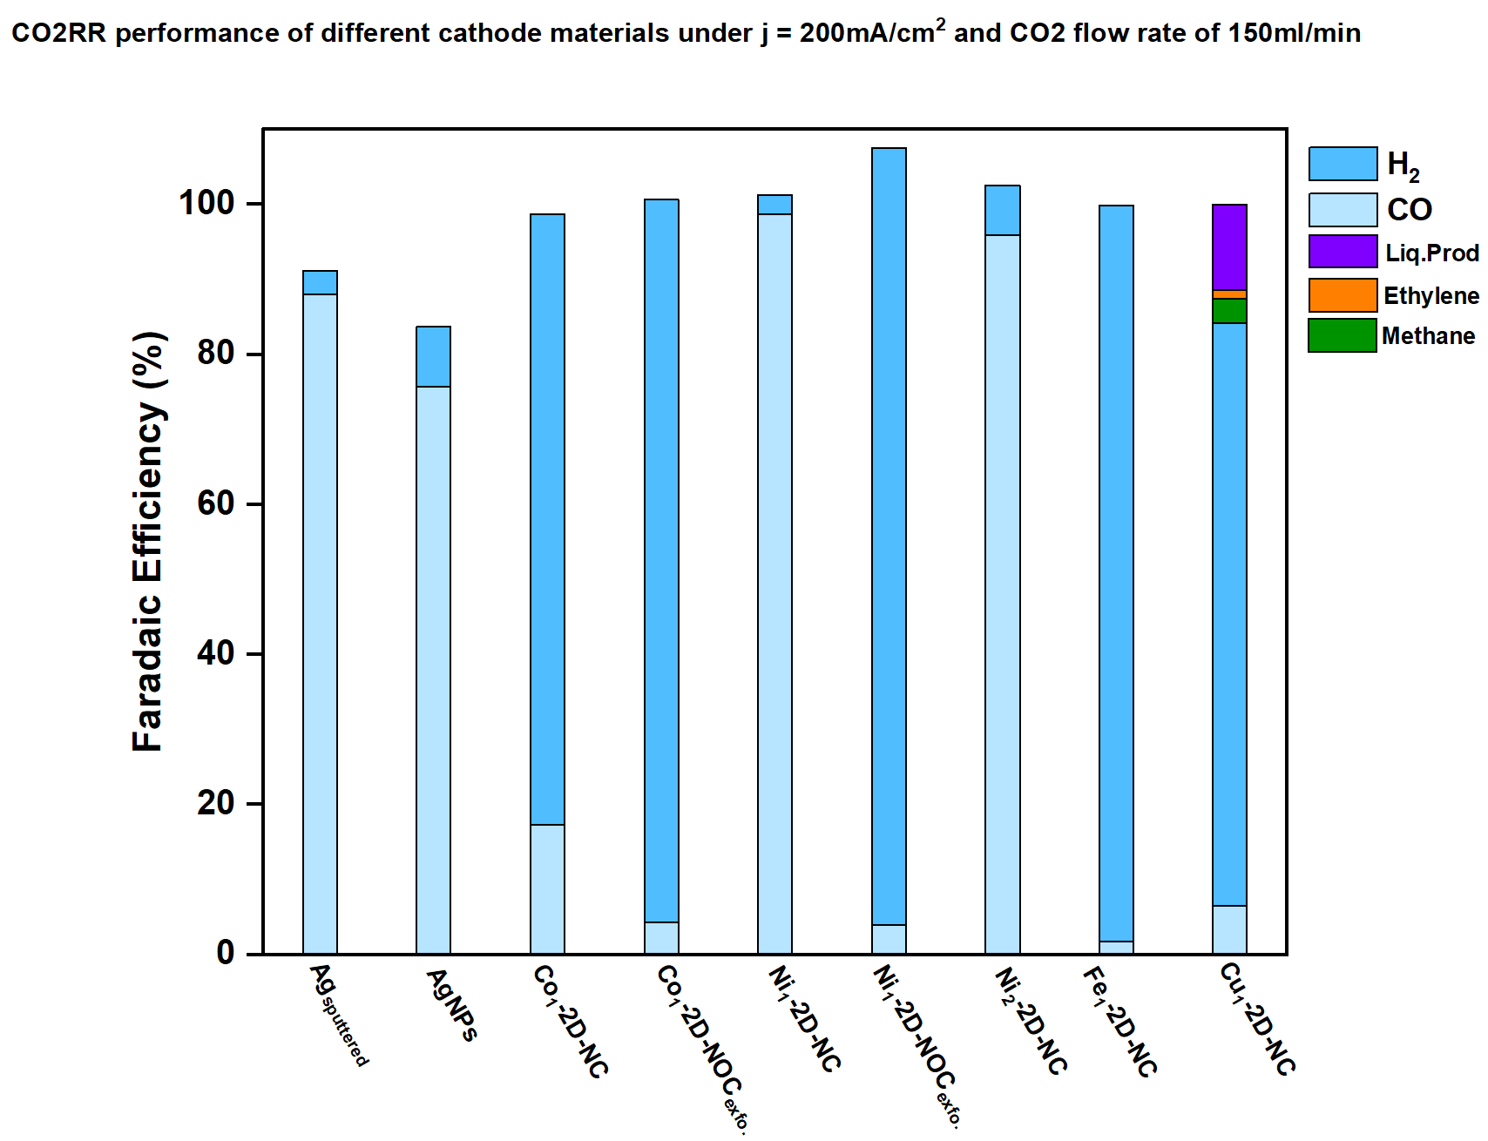
Figure 1. Faradaic efficiency of different cathode materials under applied current density of 200mA/cm² and 150 mlCO₂/min.

Influence of mass loading of Ni₁-2D-NC cathode on eCO2RR performance
Catalyst mass loading is a critical parameter significantly affecting overall performance. To solidify the impact of mass loading, Ni₁-2D-NC cathode catalysts were fabricated with varying loadings of 0.65, 0.9, and 1.2 mg/cm². These catalysts were then evaluated for CO2RR performance at 200 mA/cm² and 150 ml/min CO₂ flow rate (as shown in Fig. 2). Notably, all Ni₁-2D-NC catalysts exhibited similar CO2RR performance, with a faradaic efficiency for CO (FE(CO)) of approximately 98%. This suggests minimal influence of mass loading on overall cell performance at a current density of 200 mA/cm². To gain a deeper understanding of mass loading effects, future studies should investigate CO2RR performance at higher current densities and diluted CO₂ concentrations.

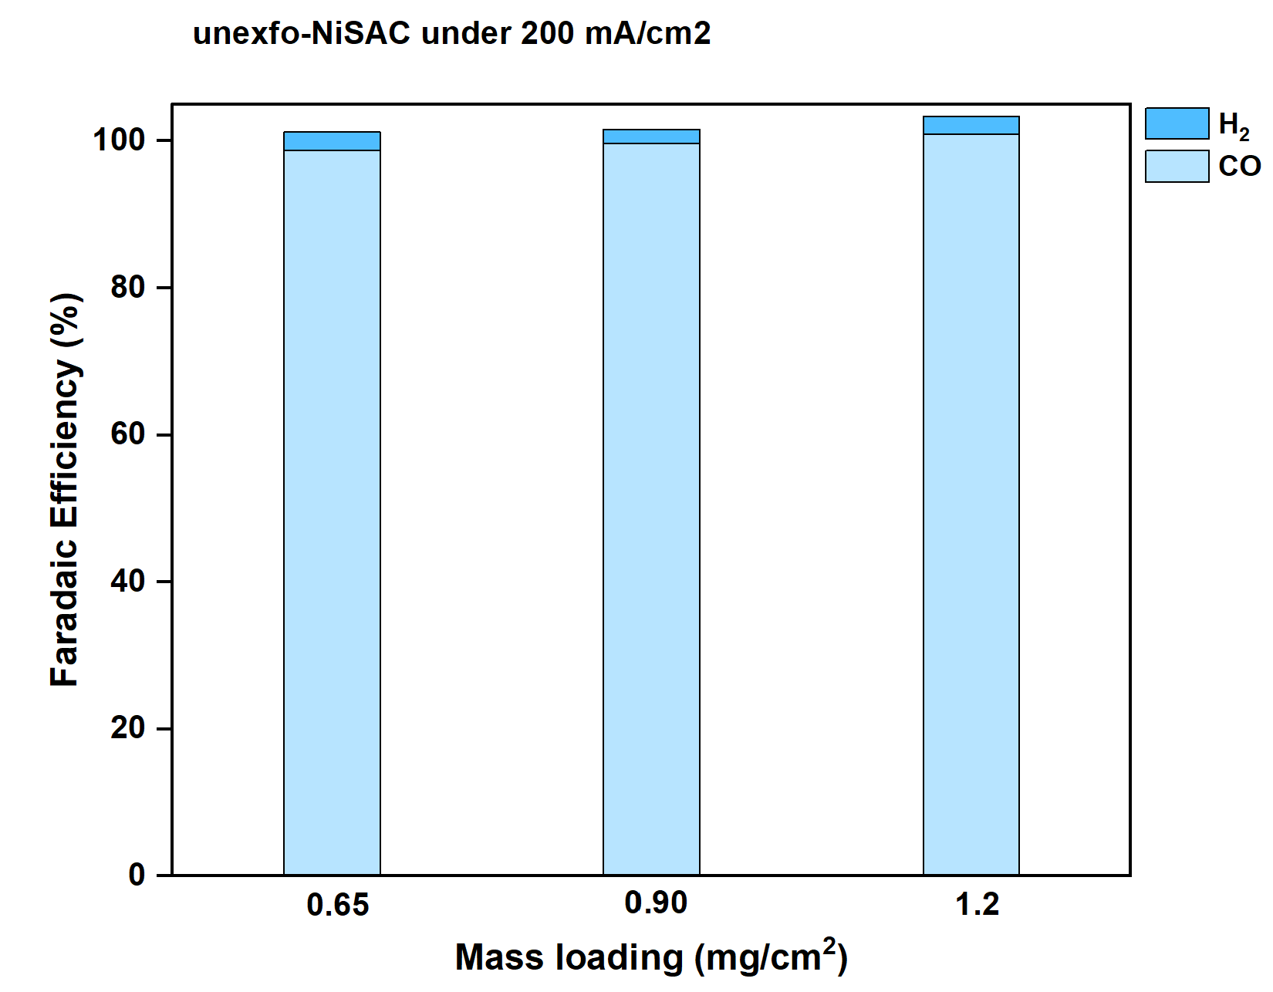
Figure 2. Faradaic efficiency of Ni₁-2D-NC cathode with different mass loading under CO₂ flow rate range of 150 ml/min at 200mA/cm².

Influence of different cathodic gas feed compositions on CO selectivity
Fig. 3a showed the %FE as a function of CO₂ flow rate under the operating current density of 200 mA/cm². After carefully adjusting the anolyte flow rate from 8 to 4 ml/min, a maximum FE(CO) of approx. 84% with significantly suppressed the HER activity was achieved under the CO₂ flow rate of 15 ml/min and 200mA/cm². These results elucidated the important of pressure gradient between the CO2 and anolyte flow rate as it could lead to the imbalance of water in the CO₂ electrolyzer. The water management requires careful attention, and if there is massive amount of water diffused to the cathode side, the GDL will likely to be flooded and CO₂ mass transport will be reduced.^{2,3}On the other hand, if there is insufficient water available at the cathode side, the protonation of CO2RR will become even harder, thus leading to highly competitive HER activity.^{3,4} The CO2RR performance with diluted 15%CO₂/85%N₂ under different studies (Total flow rate, catalyst mass loading, dried gas feed, and %Ni loading) was shown in Fig. 3b. By doing this, we enable to prescreen and grasp the cell performance under different conditions that also allows us to choose which parameters should study next. As can be seen in Fig. 3b, we can conclude that, (1) increasing total flow rate from 100 to 200 ml/min barely impacted the CO2RR performance, (2) A higher catalyst mass loading of 1.2 mg/cm² Ni₁-2D-NC showed a slight improved of CO2RR performance, (3) dried 15%CO₂/N₂ gas feed showed an increased FE(CO) of 60%, and (4) high %Ni loading (Ni₂-2D-NC) shared similar results to Ni₁-2D-NC. These indicated that the investigation of CO2RR with higher mass loading of Ni1-2D-NC and either dried or low humidified CO₂/N₂ gas feed should be further addressed. The CO2RR performance with Ni₁/N₂-2D-NC catalysts under dried and humidified gas mixture of 95%CO₂/5%O₂ was depicted in Fig. 3c. The results indicated that neither a dried CO₂/O₂ feed nor a high %Ni loading (Ni₂-2D-NC) demonstrated good performance under a 95%CO₂ and 5%O₂ gas mixture condition.
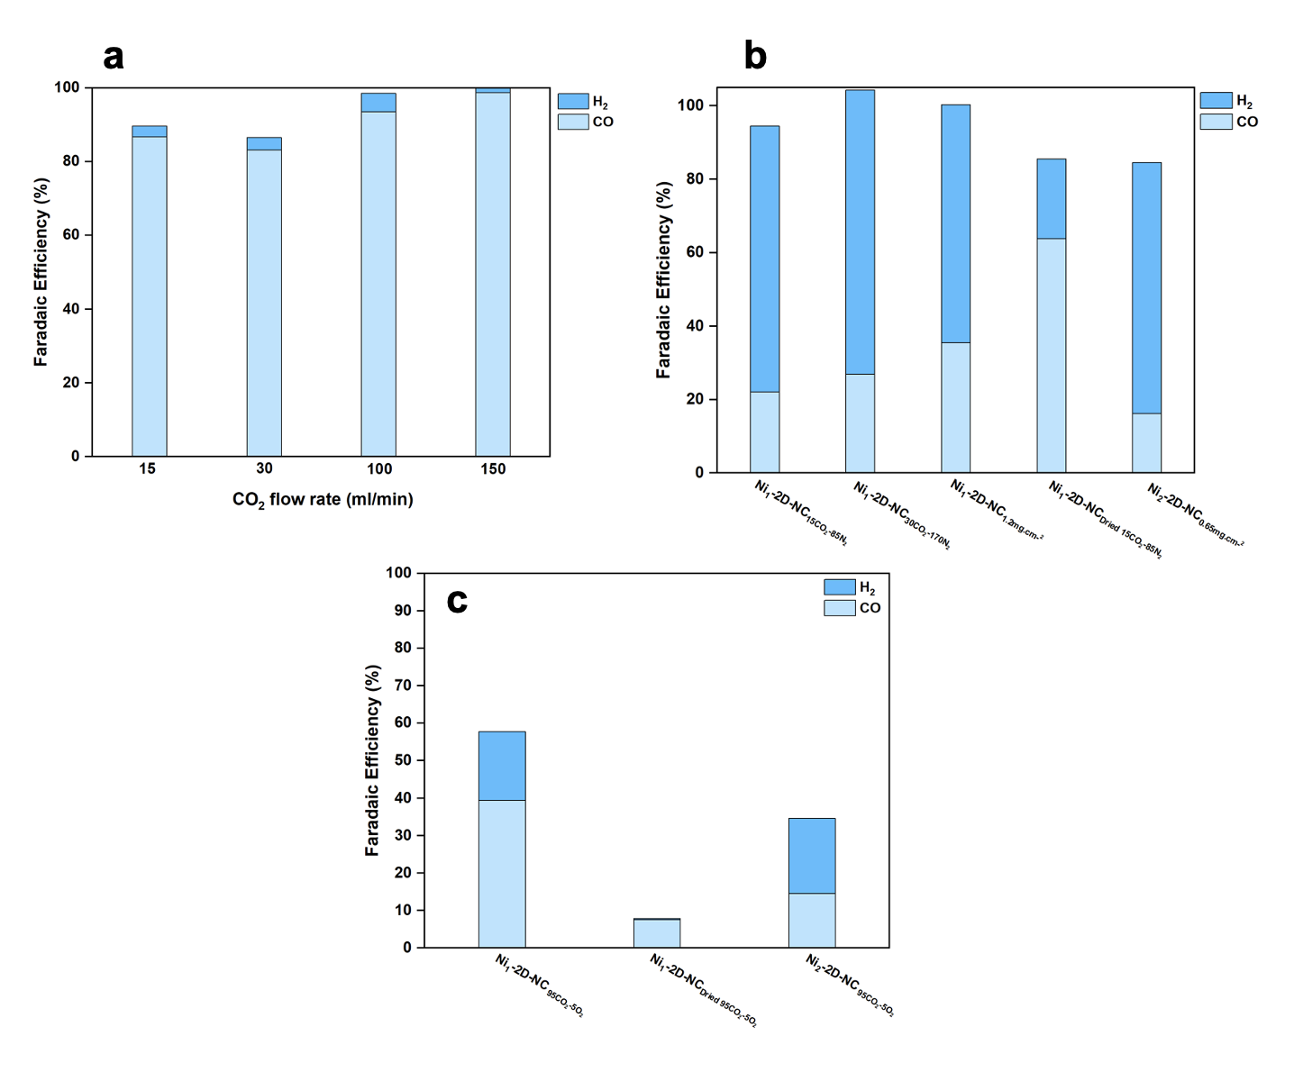Figure 2. Faradaic Efficiency of MEA electrolyzer under (a) anolyte flow rate of 4 ml/min and 15 mlCO₂/min compared to higher CO₂ flow rate, (b) a gas mixture of 15%CO₂/85%N₂, and (c) 95%CO₂/5%O₂ with Ni₁/N₂-2D-NOC cathodes at 200mA/cm².

- Summary
In summary, a higher Ni loading Ni₂-2D-NC catalyst exhibited a similar performance in faradaic efficiency (FE) compared to Ni₁-2D-NC, with an FE(CO) of ~96% and an FE(H₂) of ~4%. The Ni₁-2D-NC catalyst showed similar results regardless its varied mass loading, and further studies should be conducted. Additionally, Adjusting the anolyte flow rate from 8 to 4 ml/min maximized the FE(CO) from ~35% to 84% and suppressed the HER activity, indicating the importance of water management and pressure buildup inside the cell. The CO2RR test under a gas mixture of 15%CO₂/N₂ revealed that higher mass loading catalyst and low humidified gas feed should further be used in the study of CO₂ partial pressures, while Ni₂-2D-NC catalyst shared similar results to Ni₁-2D-NC under a mixture of 95%CO₂/5%O₂ at 200mA/cm², and higher applied current densities is suggested for the CO2RR performance.

- Upcoming tasks
- CO2RR performance of varied mass loading catalysts under higher applied current densities with a cell config. of IrO₂/AEM/Ni₁-2D-NC.
- Fabrication of IrO₂-based anode catalyst
- Investigation of CO₂ partial pressure (15, 30, 50, and 100%) under 200mA/cm²
- Investigation of different quantities of O₂ (1, 3, 5, and 10%)
- CO2RR performance under a gas mixture of 95%CO₂/5%O₂ at higher applied current densities.

- References
1. Butburee, T. et al. General Pyrolysis for High-Loading Transition Metal Single Atoms on 2D-Nitro-Oxygeneous Carbon as Efficient ORR Electrocatalysts. ACS Appl Mater Interfaces (2024) doi:10.1021/ACSAMI.3C18548/ASSET/IMAGES/LARGE/AM3C18548_0004.JPEG.
2. Yang, K., Kas, R., Smith, W. A. & Burdyny, T. Role of the Carbon-Based Gas Diffusion Layer on Flooding in a Gas Diffusion Electrode Cell for Electrochemical CO2Reduction. ACS Energy Lett 6, 33–40 (2021).
3. Reyes, A. et al. Managing Hydration at the Cathode Enables Efficient CO2Electrolysis at Commercially Relevant Current Densities. ACS Energy Lett 5, 1612–1618 (2020).
4. Wheeler, D. G. et al. Quantification of water transport in a CO2 electrolyzer. Energy Environ Sci 13, 5126–5134 (2020).

